**CHAT BOT ARCHITECTURE**

**I HAVE USED HERE DIALOGFLOW WHUCH IS BASICALLY A CHATBIOT BULIDING FRAMEWORK…DEVELOPED BY GOOGLE…**

**INTENT:**

**USWR JOKHON I KICHU QUERY KORE CHATBOT ER KACHE THAT IS CALLED INTENT**

**EX: CAN U DO THIS?**

**WHAT IS YIUYR NAME ETC ETC**

**ENTITY:**

**ENTITY BASICALLLY INTENT THEKE EXTRACT HOY..**

**EX: SUPPOSE USER CHATBOT K ASK KORCHE**

**“CAN YOU PLEASE PROVIDE ME YOUR PHONE NUMBER?”**

**EKHANE EI PURO QUERY TA HOLO INTENT**

**AAR SPECIFIC WORD “ PHONE NUMBER” ETA HOLO ENTITY**

**WILL IT RAIN TODAY?? ==>ETA INTENT**

**“RAIN” WORD ETA HOLO ==>ENTITY**

**SO AMADER CHATBOT BASICALLY INTENT ER VETOR THEKE ENTITY EXTRACT KORE…AR ENIYIS DEOENDEING ON THE CHAT BOX 1 BA MORE THAN 1 POSSIBLE**

**FULLFILL MENT:**

**NEXT STAGE OF ENITITY..**

**MOST IMPORTANT STAGE…**

**EKAHNE AMRA EKTA APP BANAI ,,MADE BY PYTHON,,BASICALLY FLUSK APP BANAI..BA WE MAY CALL IT API,,JAR KAJ HOLO EI INTENT THEKE ENITITY K CONVERT KORA..**

**SO EI FLUSK API CONVERTION KORE ,,CHAT BOT K PTHIYE DEBE…**

**THIS WAY THE ENTIRE THING WILL WORK**

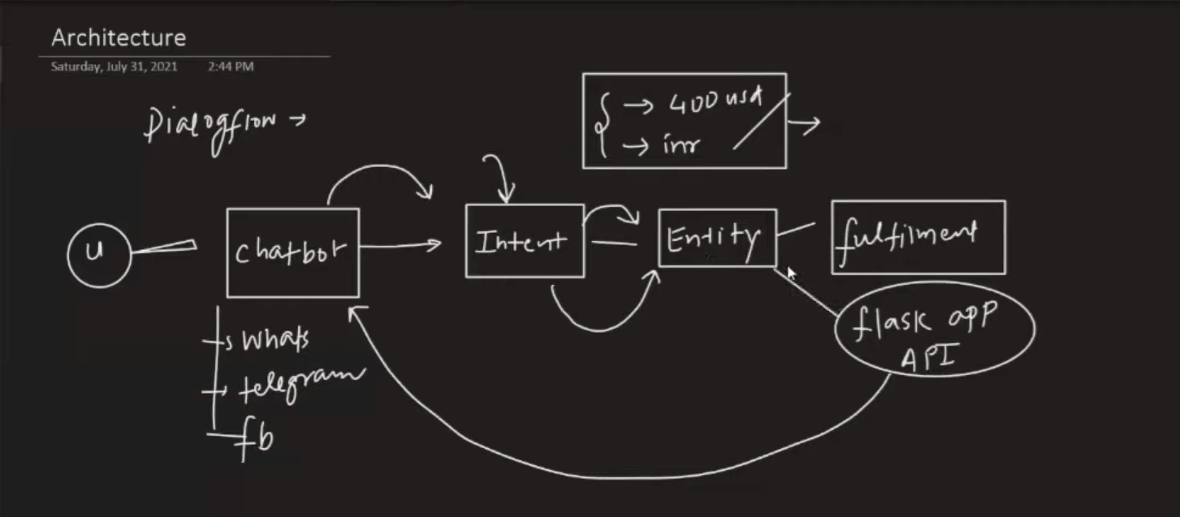

**\*/***NOW WHAT IS DIALOG FLOW???**

**=>DIALOG FLOW R AGER NAM CHILO…**

**API.AI,,JAKE GOOOGEL AQUIRE KORE ER NAM PALTE DILO DIALOGFLOW,,,,**

**E BASICALLY EKTA NLU(NATURAL LANGUAGE UNDERSTANDING) PLATFORM DEY USER K…**

**JAKE USE KORE CHATBOT BAANANO EASY HOY**

**SIMILAR AREKTA PLATFORM HOLO AWS.LEX,,,DEVELOPED BY AMAZON…**

**SIMILALRLY FACBOOK ER ACHE WIT.AI**

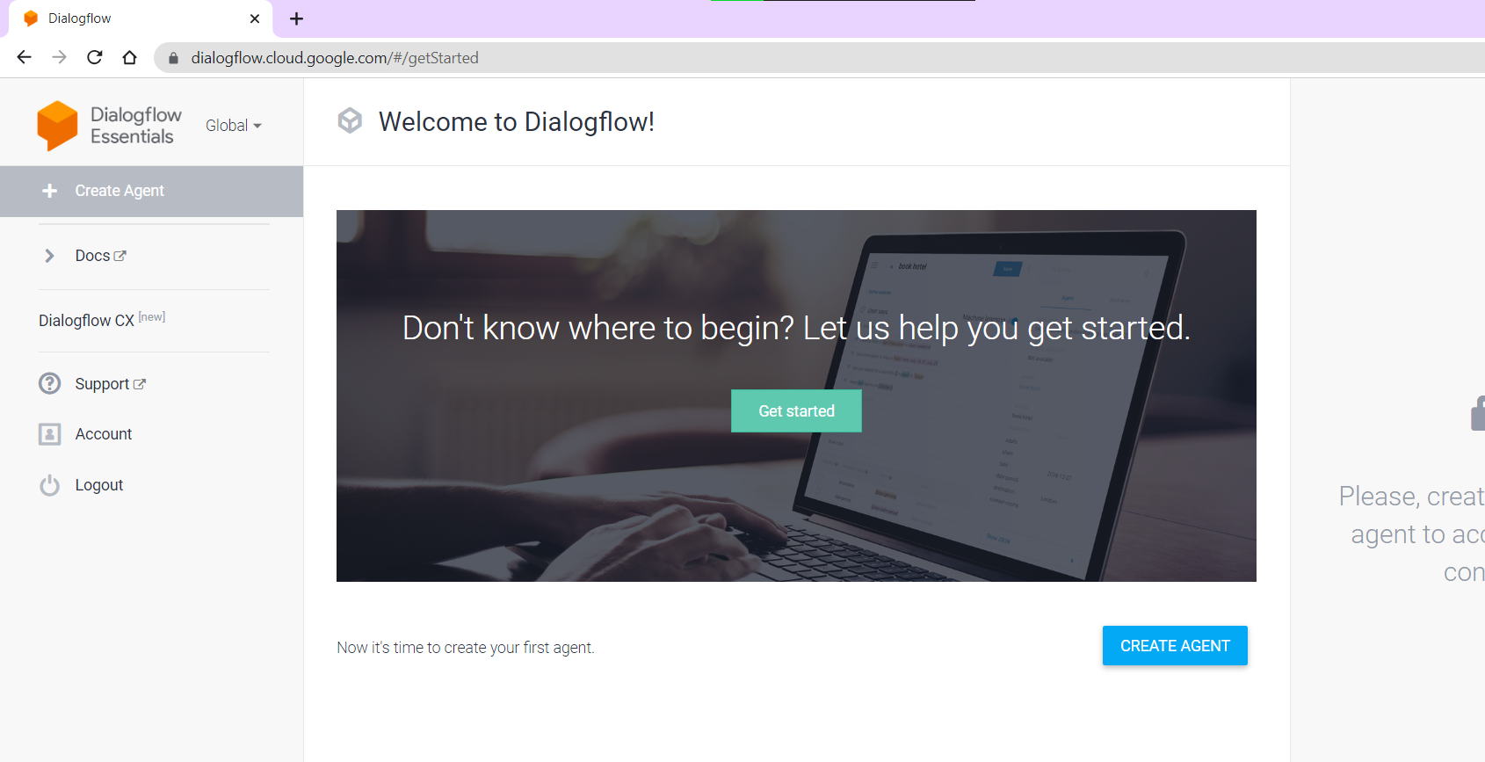

CREATE AGENT KORE NAM DIYE CREATE …

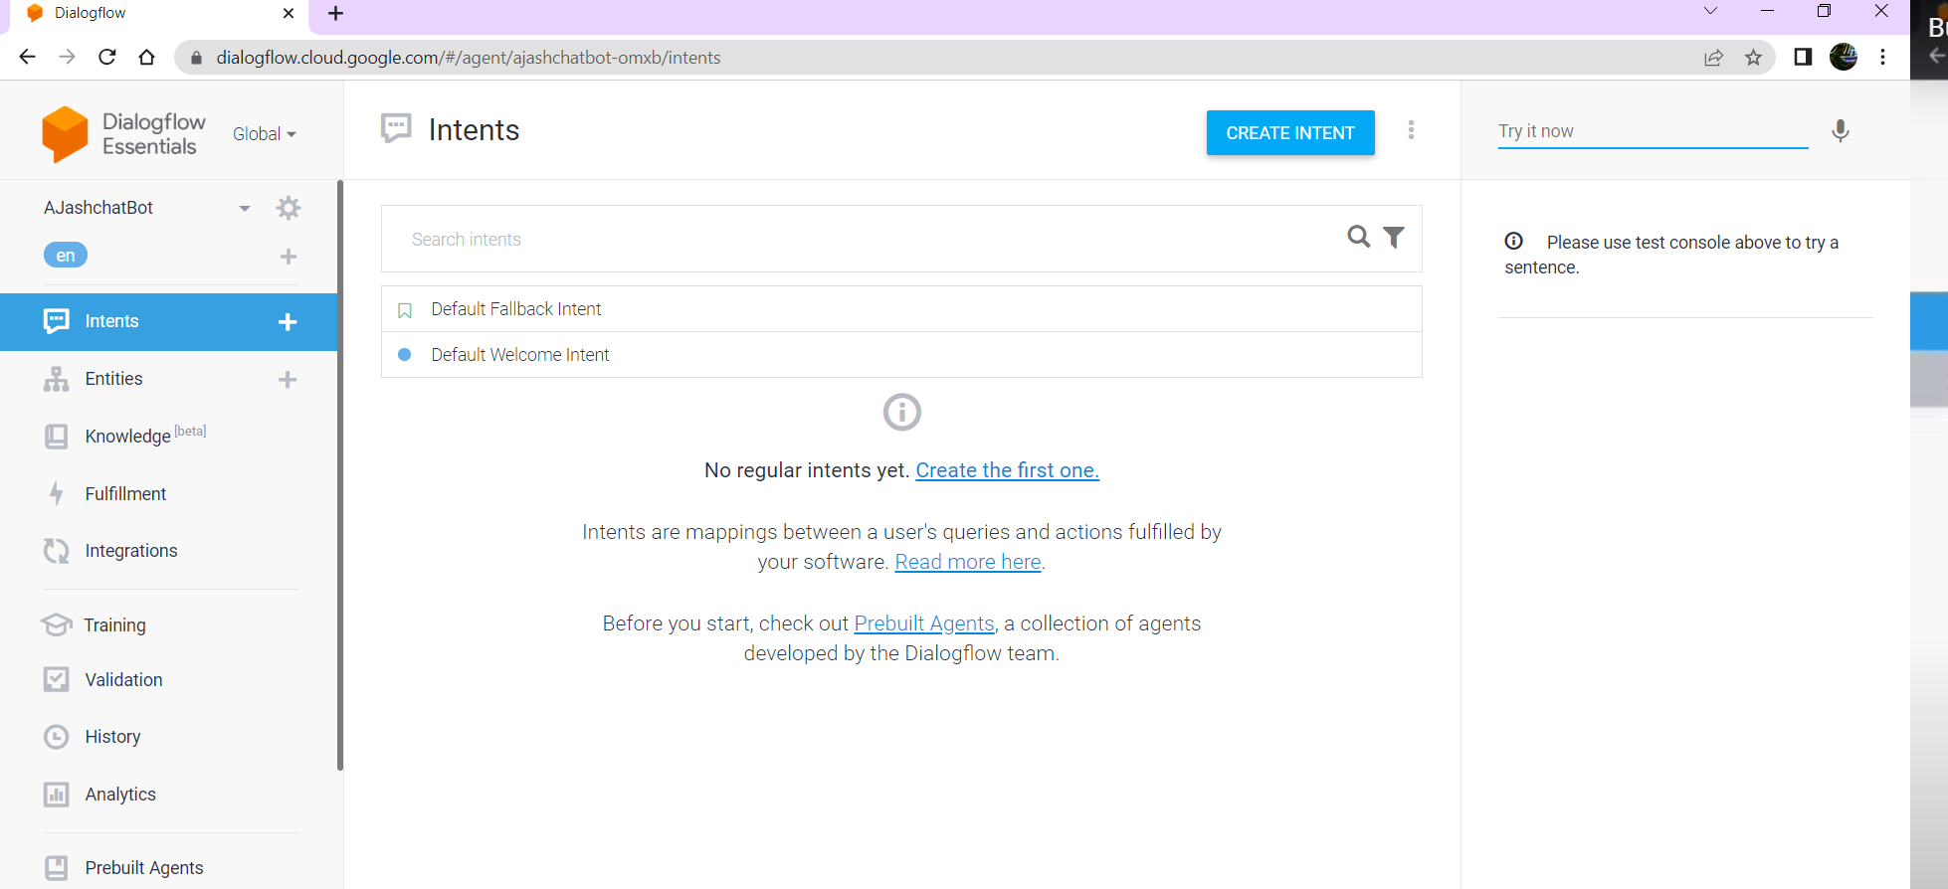

CURRENTLY AMADER KACHE INTENT PORTION ACHE..

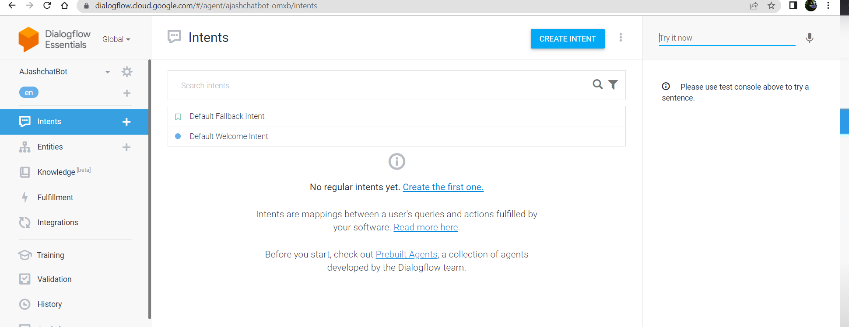

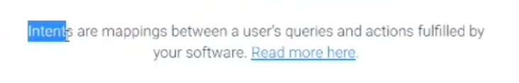

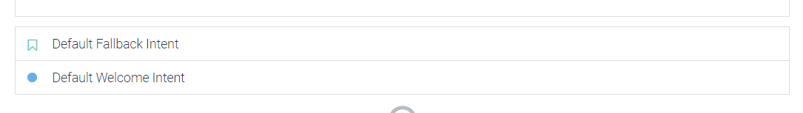

EI DUTO INTENT AMAR 1ST THEKEI PROVIDED THAKE

AAR DAN DIKER J TRY IT NOW PORTION,,TA SEKAHNE ALWAYS CHATBOX LIVE THAKE

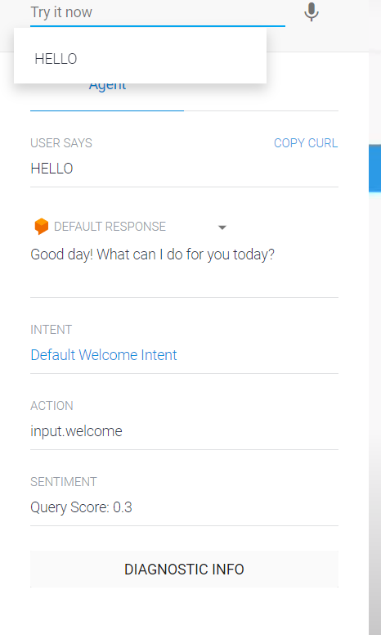

NOW QUESTION HOOLO HELLO BOLA MATROOI CHATBOT KI KORE BUJHLO KI REPLY DITE HBE BOSS////==>

=> ANSWER IS THROUGH INTENT

BCZ JOKHON I AMI HELLO BOLLAM,,AT ONCE DEFAULT WELCOM IINTENT TA TRIGGERED HOLO BOSS

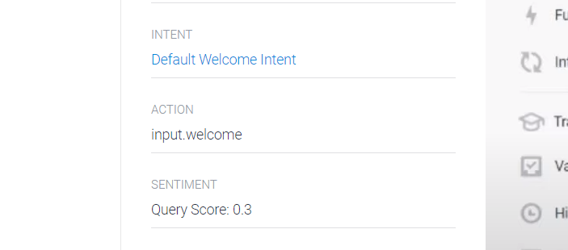

AR JAR ACTION HBE INPUT WELCOME

**\*\*\*SO AMADER SURUTEI BY DEFAUKT J J INTENT TA PROVIDE THAKE SETA JANI ,,,TAR MODHYE DEFAULLT WELCOME INTENT ER KAJ O DEKHLAM AMRA..**



**AAR EKTA INTENT HOLO DEFAULT FALL BACK INTENT:**

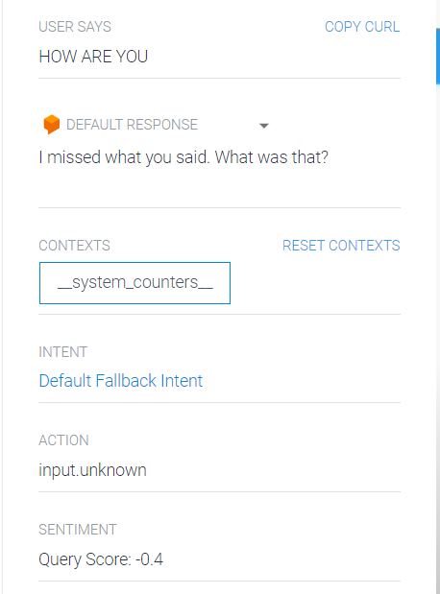NOW IF WE OBSERVED FALLBACK INTENT TA TRIGGERED HOYECHE…

**\*\*\*SO FALLBACK INTENT HOLO SEI INTENT ,,JOKHON AMAR CHAT BOX BUJHTE PAARBENA KI INTENT TRIGGGERED HOWA UCHIT,,THEN ETA TRIGGERED HOYE JABE,,,,**

**So amra aro intent create korbo….tar jonno amra create intent e jabo…**

**THEN HHELP NAME ER EKTA INTENT BANABO**

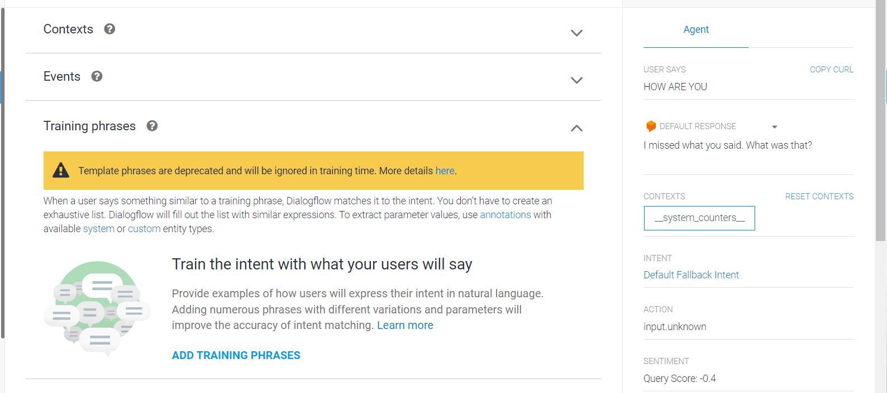

JEMON EKTA PART HOLO :

**CONTEXT:**

**MAN EUSER CURRENTLY KON CONTEXT E KOTHA BOLCH E??**

**JEI QUESTION TA AKTU AG KORCHILO..SEI CONTEXT TAI KI USER CONTINUE KORCHE NA ONNO..SEGULO EKHANE DEFINE KORA THAKE BOSS…**

**EVENTS:**

**JAVASCRIPT ER MOOTO AMRA EKHANE EVENT K TRIGGERED KORTE PARI**

**TRAINING PHASE:**

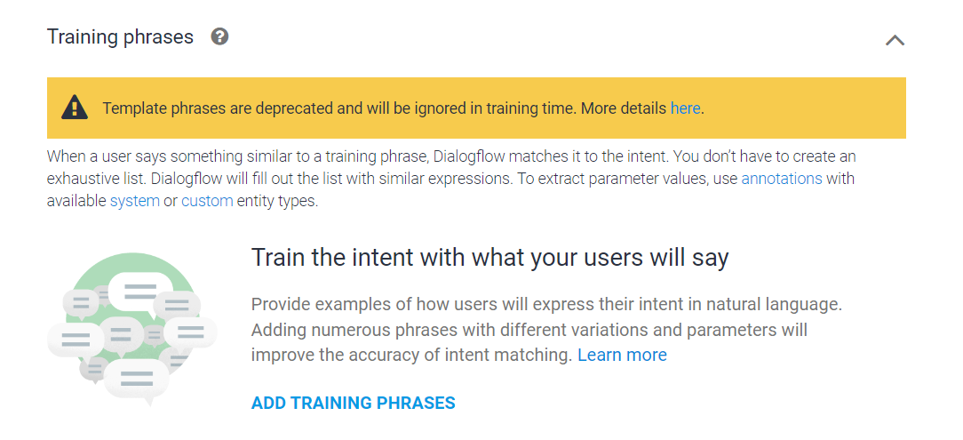

EKHANE AMDER SOB ROKOM POSSIBLKE SCENERIOS VABTE HBE …J JOTO ROKOM POSSIBLE WAY TE USER AMADER CHATBOX THEKE HELP NITE PARE ,,,SEGULO AMADER IMPLIMENT KORTE HBE…

AAR SEI SEI PHRRASES GGULO AMAKE INTENT K BOLTE HBE…

THEN ADD TRAINING PHASE E CLICK KKORTE HBE BOSS…

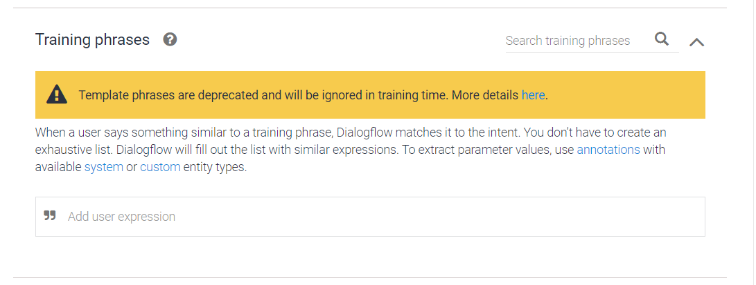

So FOR HELP PUROPOSE I HAVE PASSED SOME PHRASES:

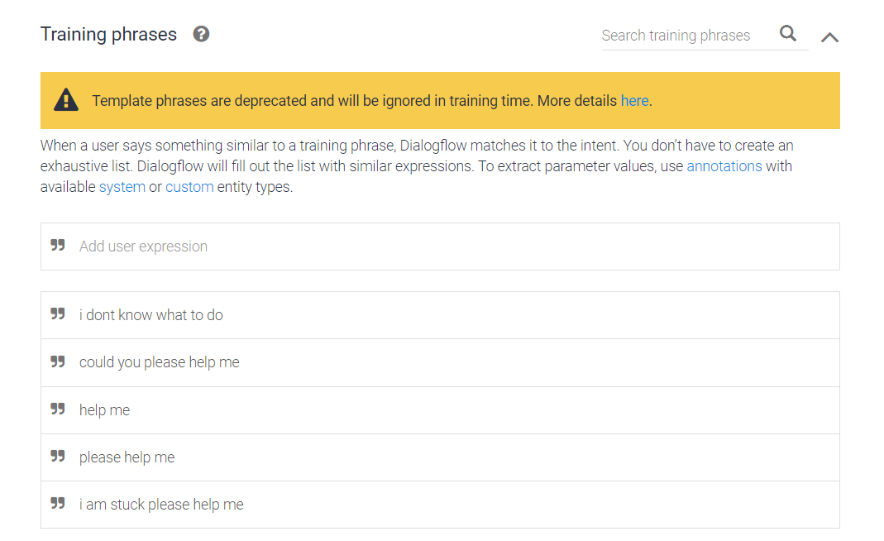

THEN SAVE KORA MATRO…

NLU MODEL OF DIALOGFLOW WILL AUTOMATICALLY START TO TRAIN THE CHATBOX…

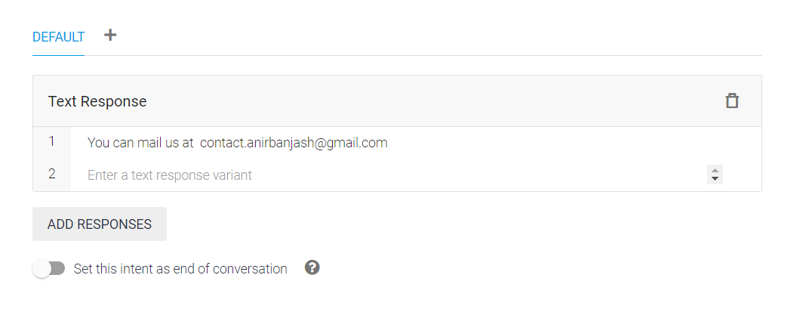

So oi sob question er eson answer hbe,,mane response hbe..

**BASICALLY HELP ENTITY THAKLEI EI RESPONSE TA KAJ KORBE**

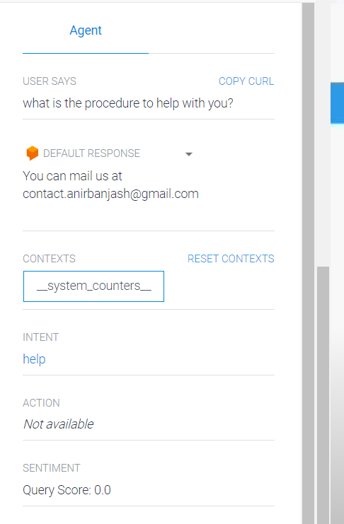

**\*\*\*HOW I CAN GIEV A PERSONALITY TO CHATBOX:**

**:MANE USER jate feel KORE SAMEN JAR SATHE KTTHA BOLCHI SE KONO MANUS I ..**

**TAR JJONNO WE WILL USE SMALL TALK:**

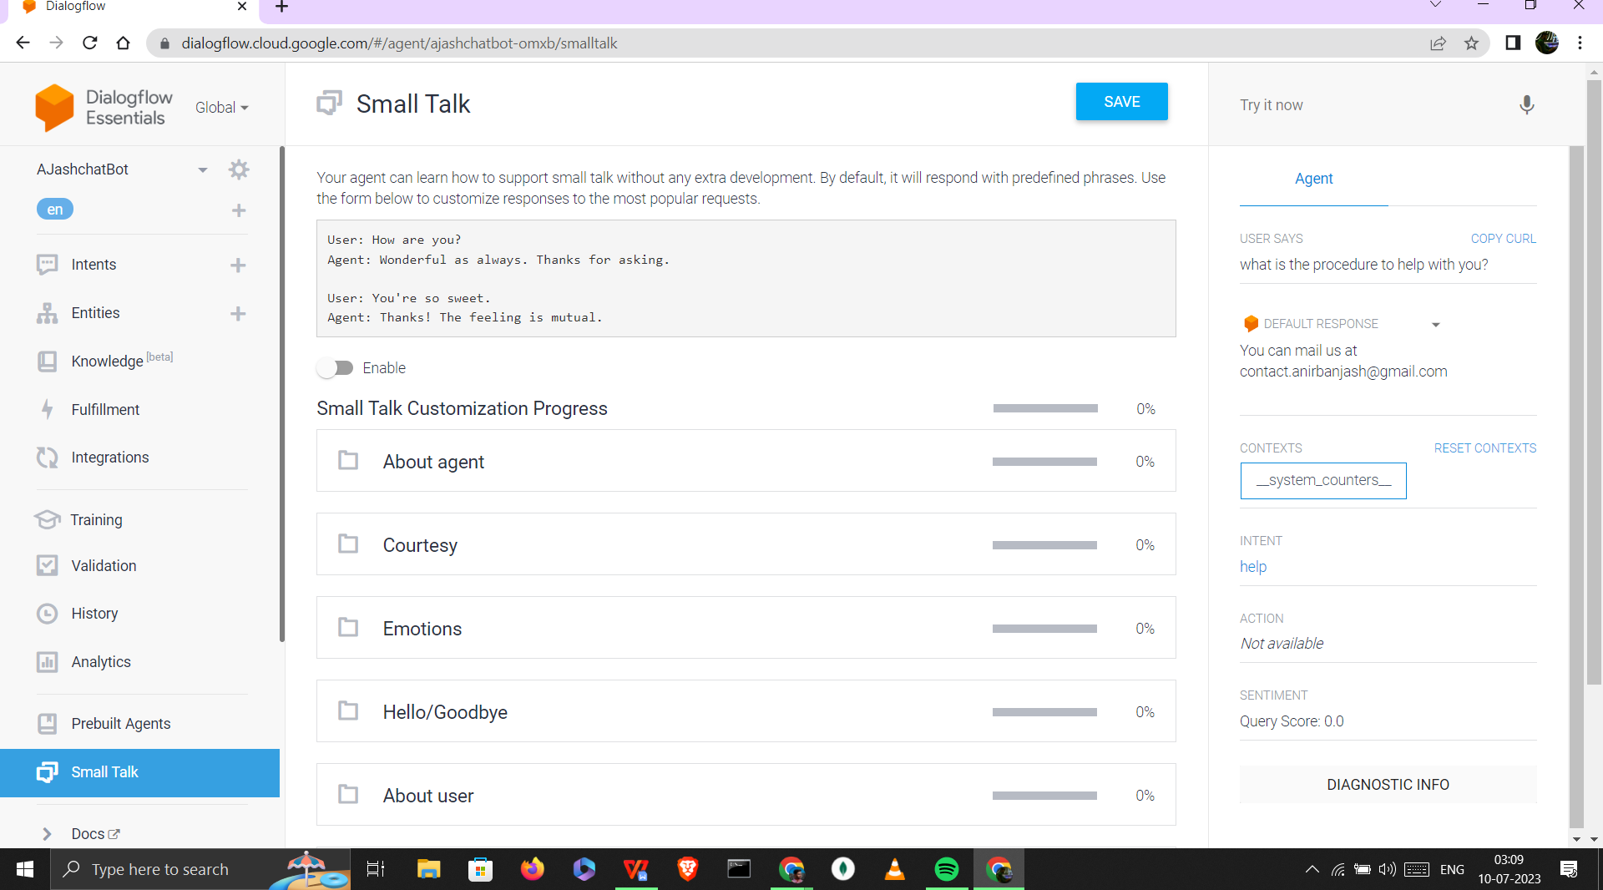

NOW AS DIALOGFLOW ONEK DIN DHORE KAJ KORCHE..SO ERA USER DARA JIGGESH KORA MOST COMMON QUESTION GULO STOR EKROE REERHCHE,,AMAKE JUST SEI QUESTION GULO R ANSWER NIJER MOTO PROVIDE KRE SET KORE DITE HBE

**JEMON ABOUT AGENTT SECTIONE ESOB DEWA CAHE:**

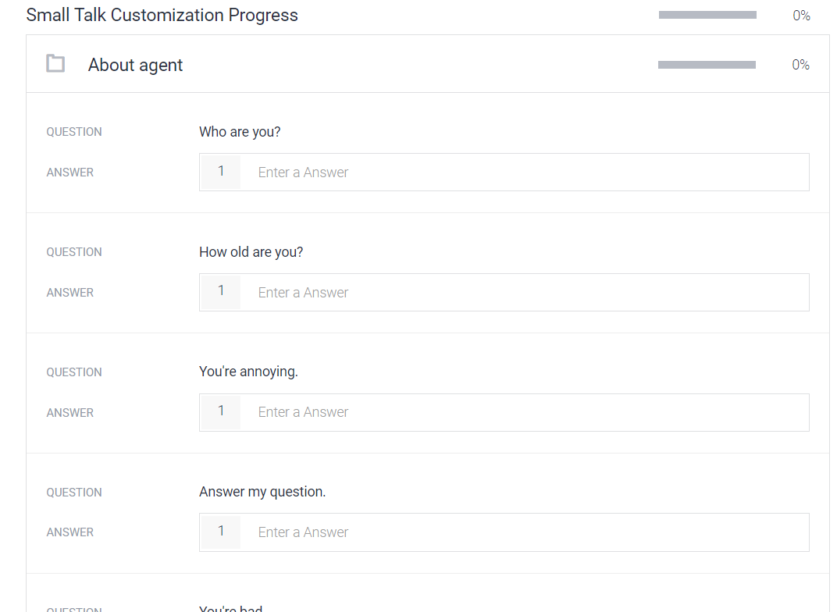

ONEKE ONEK UT POTANG QUESTIONS ASK KORE ,,TAR ANSWER AMADER READY RAKHTE HBE BOSS…

So SMALL TALK E SOB ANSWER DEWA R ..POR ,,,

WE WILL MAKE A CUURENCY CONVERTER..

**FOR THAT AMRA REKTA INTENT BANALAM CURRENCY CONVERTER:**

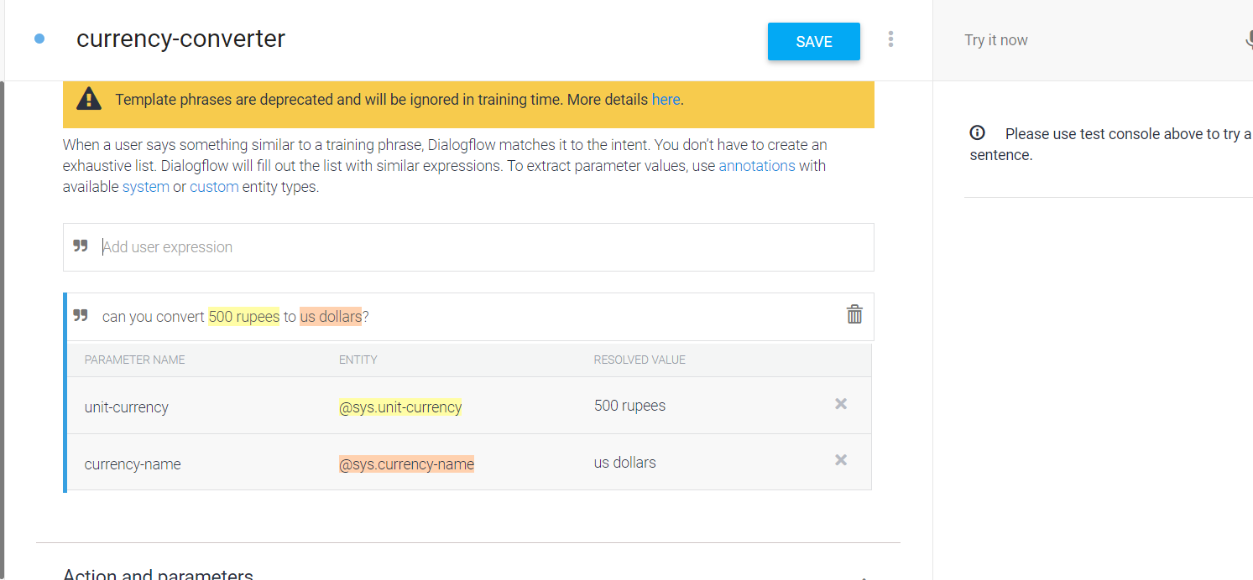

NOW JOKHON I CURRENCY CONVERTER ER TRAINING PHASE E KONO PHRASE DILAM,,,E KICHU JINIS K HIGGLIGHT KORE DILO WE CAN SEE THAT ABOVE…

SO BASICALLY EI EKHANE 500RS AAR US DOLLAR,,EGULO KI??

=>ENTITY…SO ER RESPECT EI ANSWER TA ASE…

**NOW HOLUD TA K UNIT CURRENCY BOLCHE BCZ…EKHANE NUMBER DEWA ACHE…BUT AREKTA ENTITY TE KONO DIGIT NAI JUST TEXT,,BUT EI DUTO JINI SI AMAR KAGBE BOSS..**

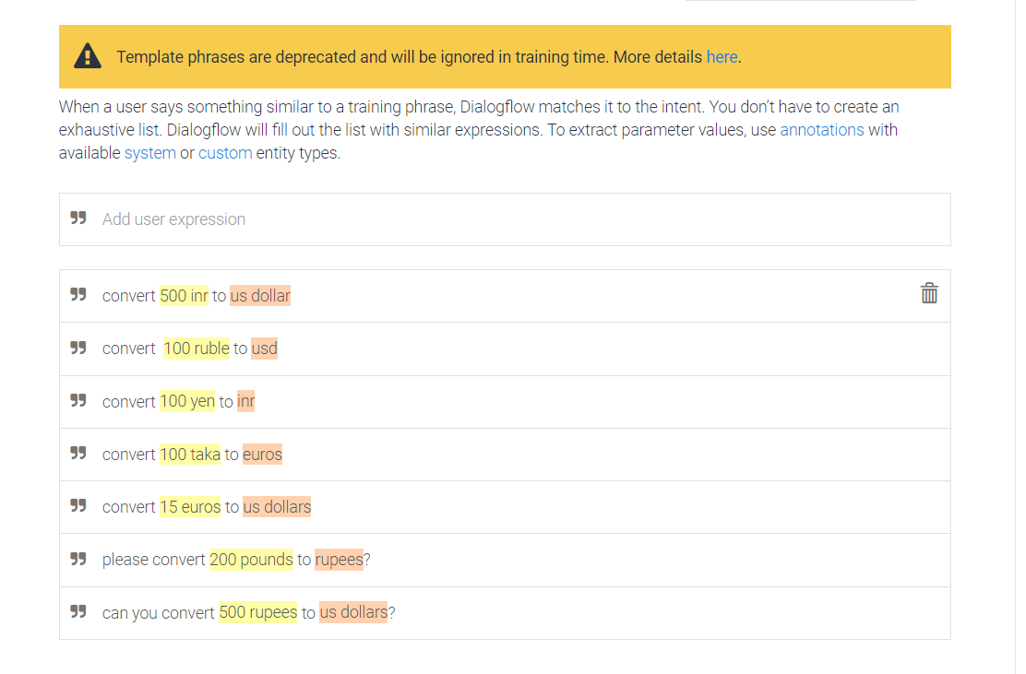’

EKAHNE MULTYPLE POSSIBILITIES DIYECHI ..NOW EHANE HPLUD GULO UNIT INTENNTITY HISEVE DENOTE KORECHE AAR PINK GULO CURERENCY

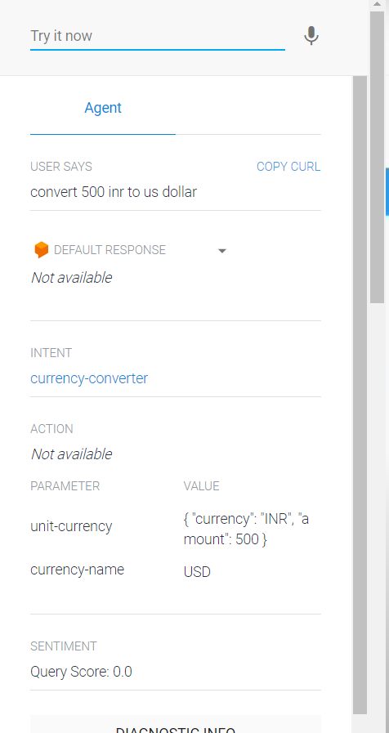

SO WE CANN SEE THAT EKAHNE EI PHRASE TA DEWAR POR CHATBOT AUTOMATICALLY AMADER CURRENCY-CONVERTER K TRIGGERED KORE DIYECHE

AAAR TRIGGERED ER SATHE E UNIT CURRENCY AAR CURRENCY NAME E VAG KOR EDILO ENNTITY K

AAR E KINTU AUTOMATIC SHORT FORM E NIYE NNILO..

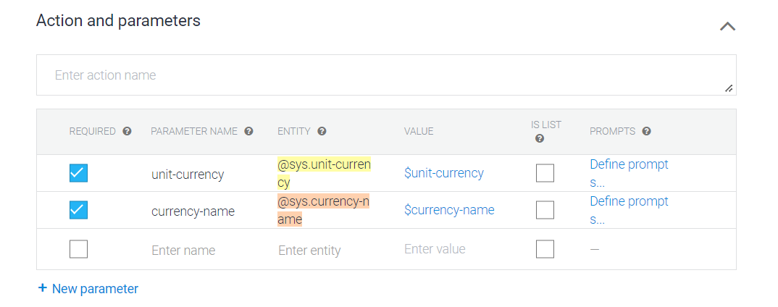

**Now AFTER THAT ACTION AND PPARAMETER E GIYE REQUIRED SECTION E GIYE UNIT CURRENCY AAR CURRENCCY-NAME E GIIYE TICK MARK DILAM,,ETAR MANE HOLO ,,JOTO KHON NA AMR CHAT BIT SUTO JINIS PACHE FURTHER EGOBENA BOSS..**

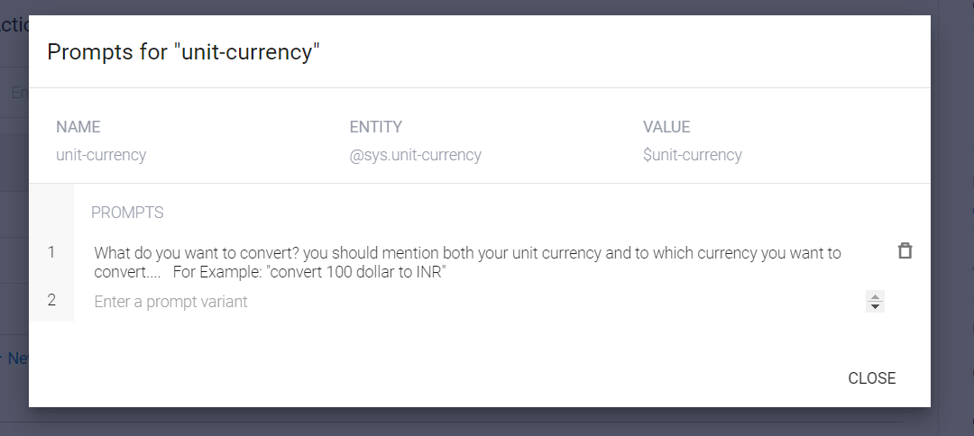

BASICALLY SUPPOSE USER EKTA INOPUT DILO ,,THEN AREKTA DILONA,,MANE UNIT CURRENCY DILO BUT KISE CONVERT KORTE HBE BOLLONA.,,,EI SOB CASE E PASE E ACTION SECTION E EKTA PROMPT BOLE JAYGA ACEH OKHANE AMRA LIKHTE PARI J AMAR KI CHAI BOSS…MANE USER ER ACTUALLY KI FORMAT E DEWA UCHIT

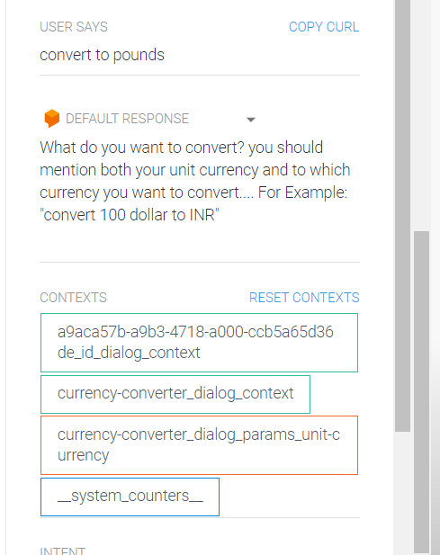 ekta PRT DINI ,MANE KI CONVERT KORTE CHAI MANE UNIT ENNITY TA DINI TAI EROM DEKHACHE

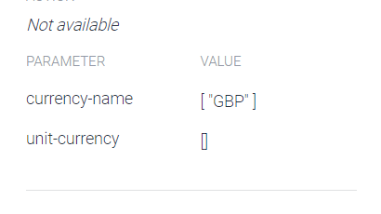

AS AMRA UNIT CURRENCY DINI TAI ,,CURRENCY NAME E GBP ACHE BUT UNIT CURRENCY NAI

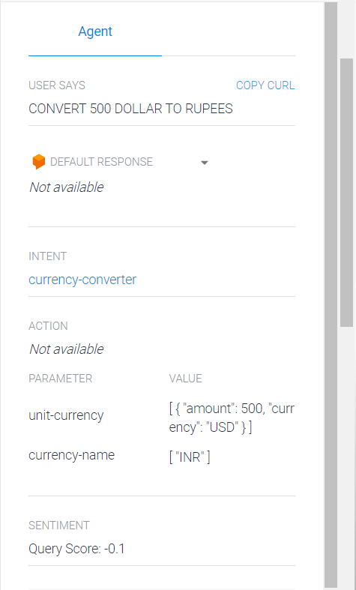AAR DUTO DEWA THAKLE DUTOI ASCHE BOSS…

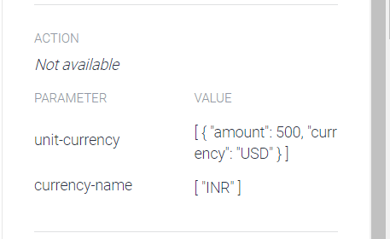

**NOW AMADER INTTENT THEKE J PARAMETER GULO PACJHHI EI,,PARAMETER GULOKE PYYTHON FLUSK APPLICATION E E PATHABO,,JEKAHNE ACTUALLY EI CONVERTION TA HHBEE…**

**AAAR RESULT BACK KORBE…**

**\*\*\*\*NOW SOMETIME IT MAY HAPPENED THAT ,,AMADER J PYTHON FLUSK API,,ER SERVER JODI BY ANY CHANCE DOWN HIYE JAY,,IN THAT CASE EMON JANO NA HOY J USER ER KACHE KONO OUTPUT JACHENA,,TAR JONNI EKTA DEFAULT MSG AGE THEKE SET KORE RAKHA JAY,,EISOB SITUATION ER JONNO…**

**FOR DEFAULT RESPONSE**

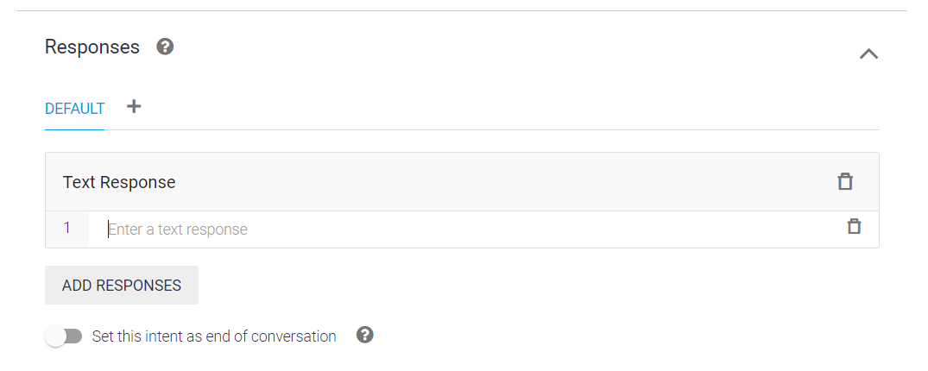

EKHANE RESPONSE E GIYE DEFAULT SECTIONE GIE ADD KKORE DEBO…KICHU

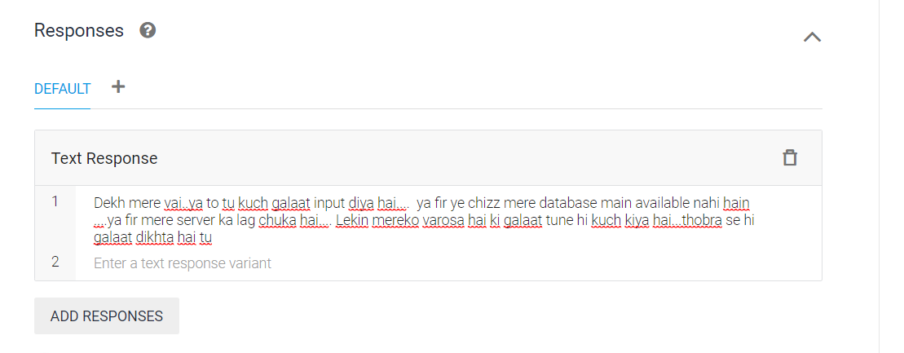

**\*\*\*\*now AMI J PYTHON APPLOCAION BANABO TAKE EXACTLY KI PATHABO**

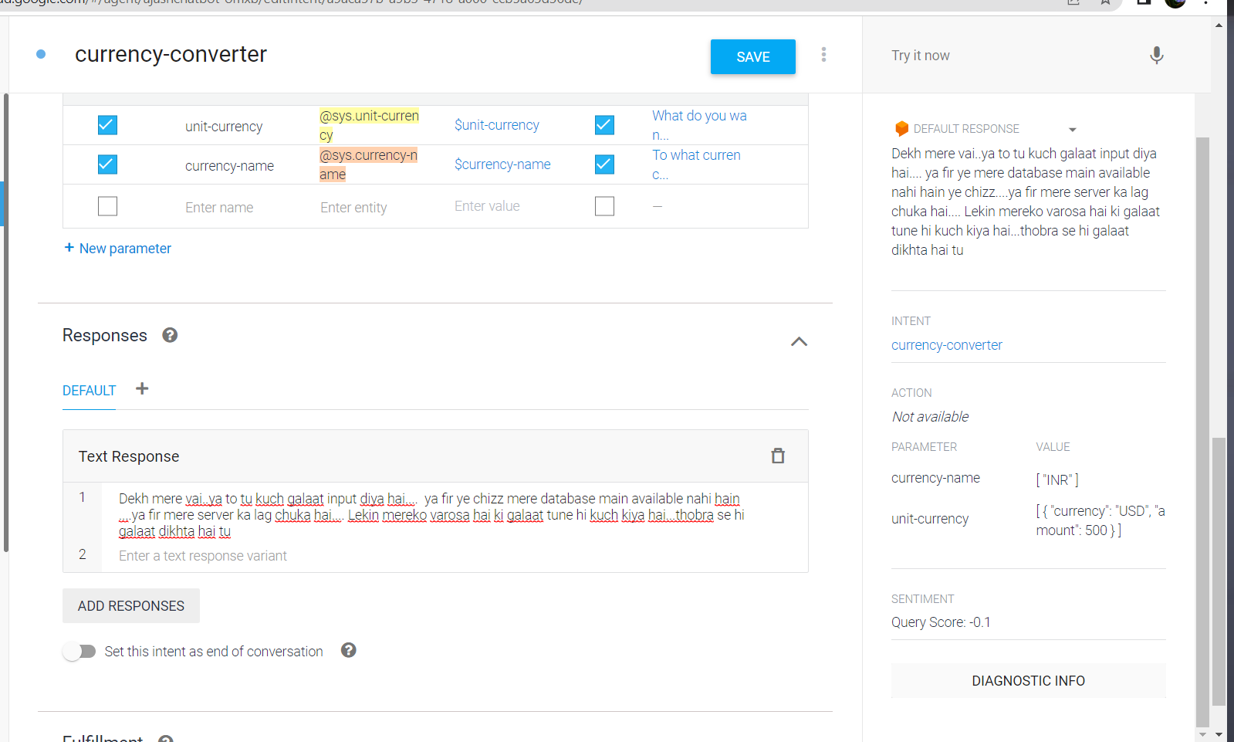

NOW NICHER RIGHT CORNER E LEKHA ACHE DIAGNOSTIC INFO BOLE…

OTAY CLICK KORLE EROM EKTA ASBE  
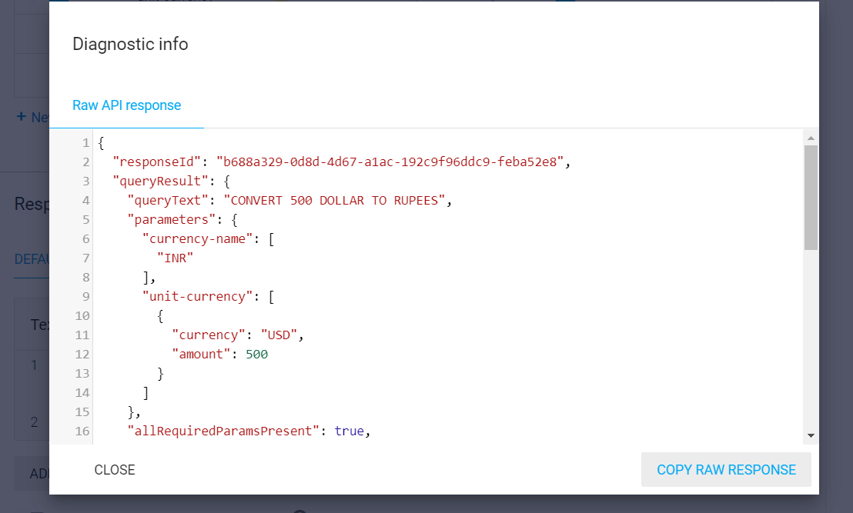

BASICALLYE ETA EKTA JSON OBJECT JETA AMAR PYTHON APPLICATION K DEBO..

**ETA DIYEI AMI AMAR PYTHON APPLIICATION K CHATBOT ER SATE CONNECT KORBO…**

**AMRA PYTHON I SUDHU USE KORTE PARI T NA,,AMRA PHP USE KORTE PARI BA,,JAVA USE KORTE PARI..NODE JS O USE KORET PARI**

**Now amra flusk application banabo…**

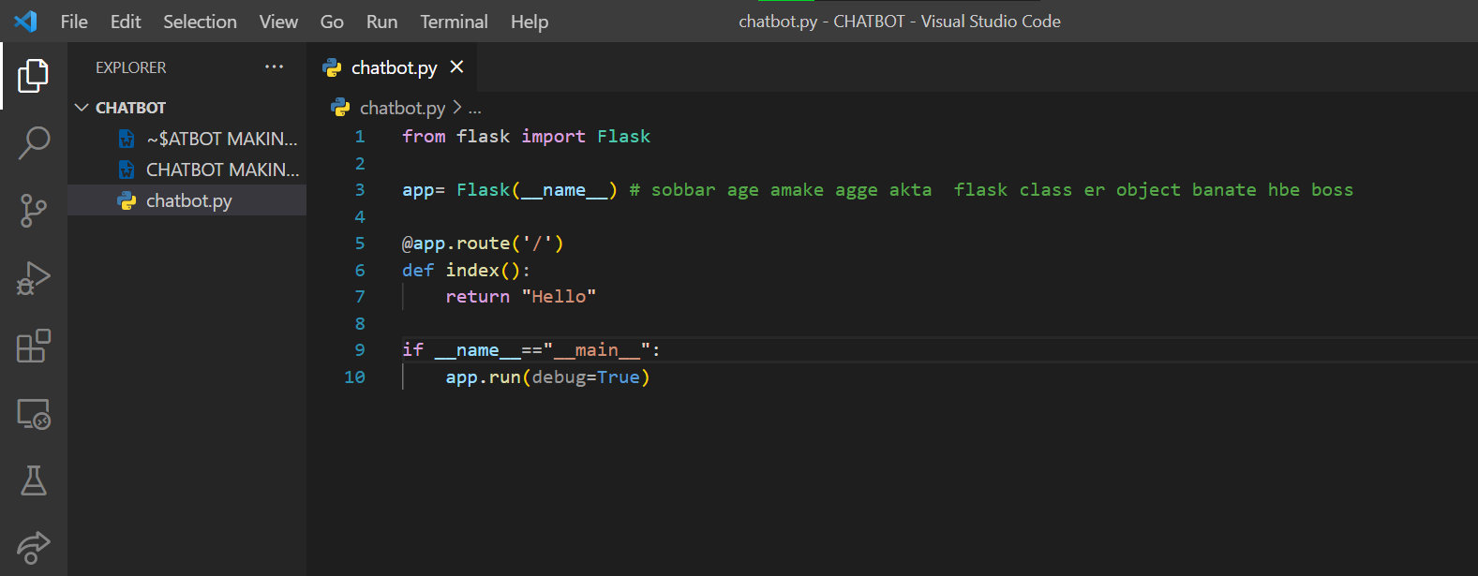

Eta likhe run korlalei flist app ekta perticular port e run korbe ,,,

**Ei code ta HBE AMADER CHATBOT ER BACKEND**

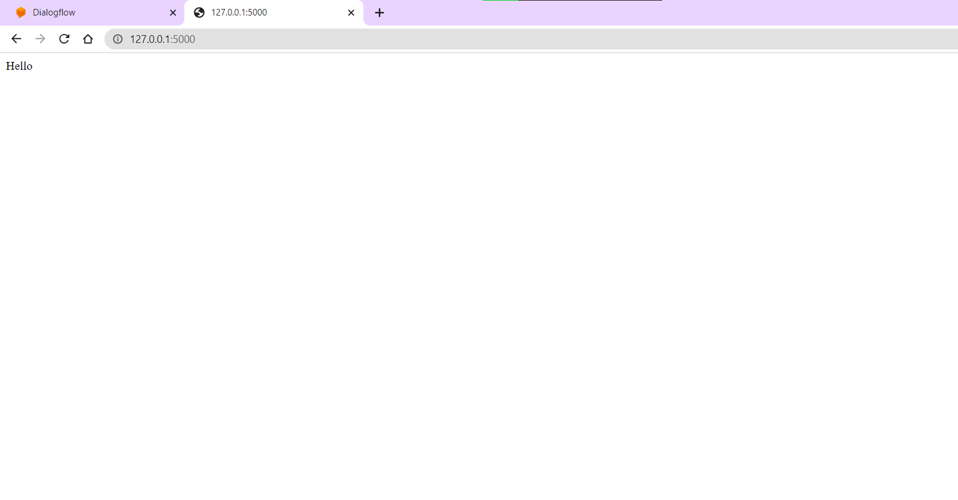SO FLOW WILL BE LIKE THAT:

JSON FILE TA AMRA BACKEND E EI FLUSK E DEBO…SEKAHNE CALCULATION HIYE ABAR BACK KORE DEBO

**\*\*\*\*ONE VERY IMPORTANT PROBLEM,,,:**

**AMADER CHATBOT SETA CHOLCHE ONLINE E ,,,AR AMMDER J BACKEND SETA CHOLCHE MACHINE E,,MANE OFFLINE…SO HOW CAN I COMMUNICATE BETWEEN THEMM**

**\*\*\* SO WE EILL USE A SOFTWARE NAMED NGROK:**

**ETA BASICALLY AMAR MACHIEN ER KONO PORT K ONLINE NIYE ASE ETAI KAJ…BUT ETA ONLY 8 HOUR ER JONNO,,,BUT JOKHON FINAL PRODUCTION KORBO AMRA THEN AMR ONNO KICHU US EORBO**

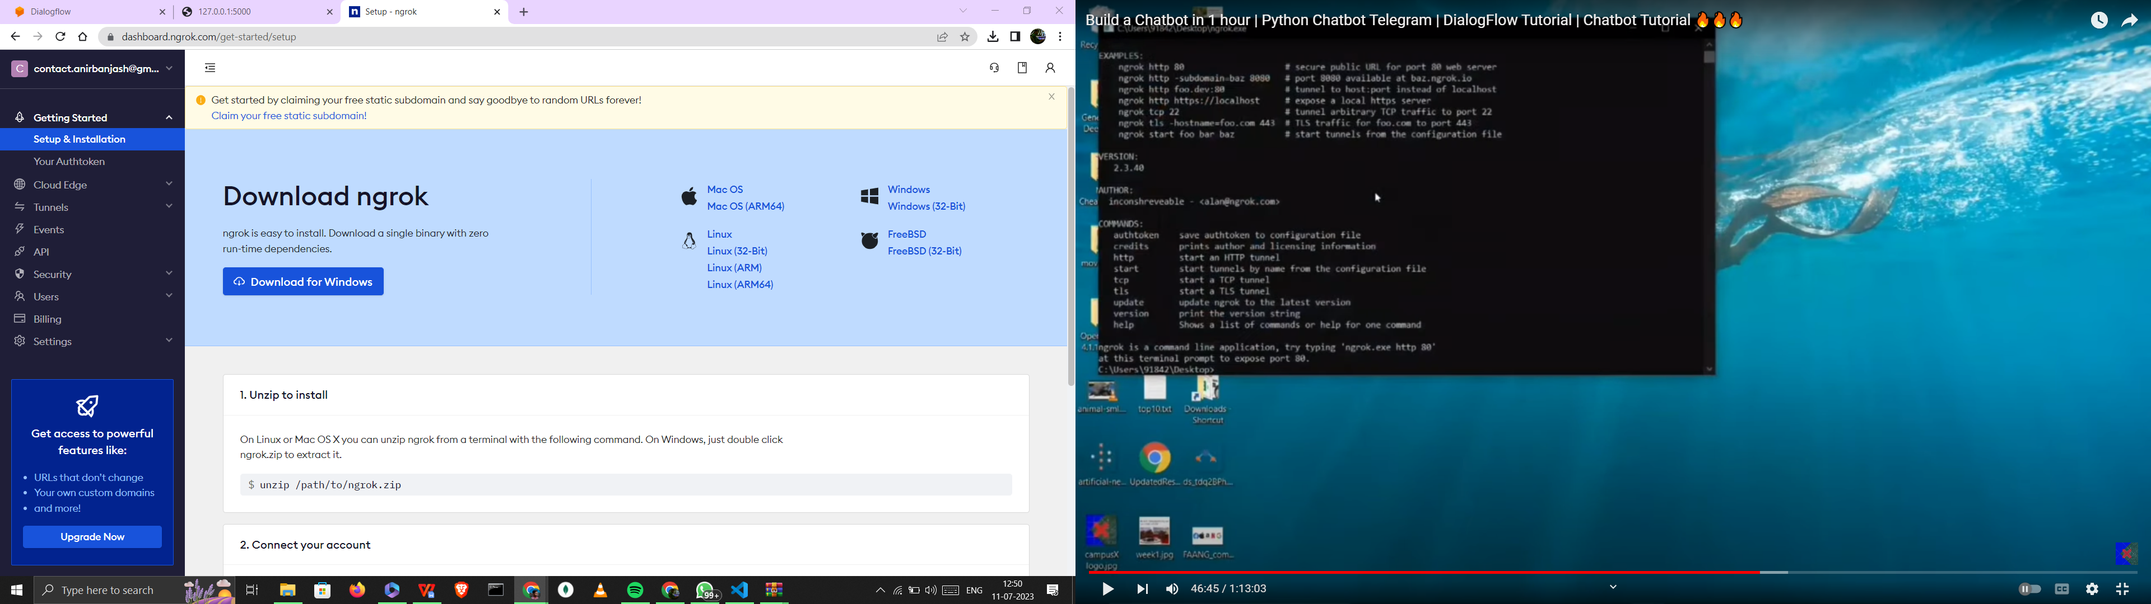

DESKTOP E GIYE EXTRACT KORLAM ETA KHULLO:

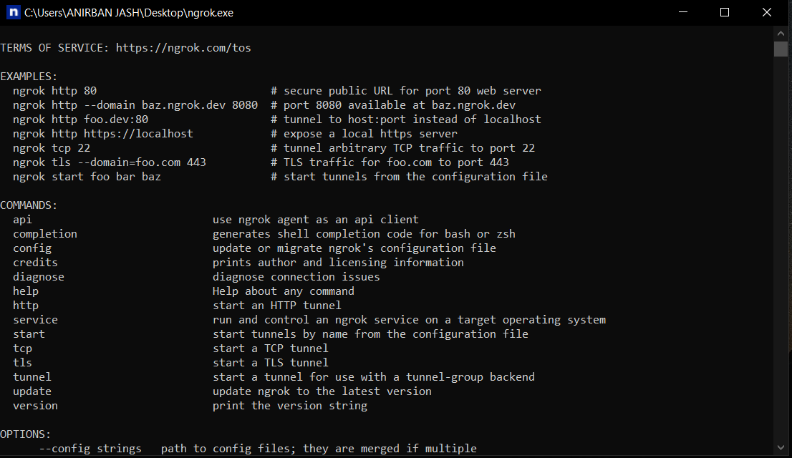

Then EKHANE TYPE KORBO

“ngrok.exe http 5000”

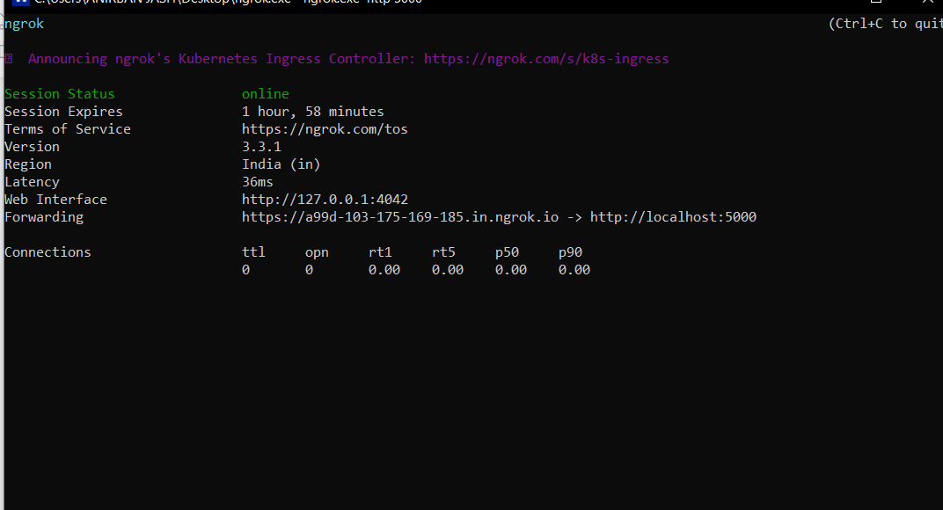

Erom asbe then…ekahne dekha jaceh 2 hour er jonno amionline thakte oari

NOW FORWARING WALA LINK TA NIYE PASTE KORLE

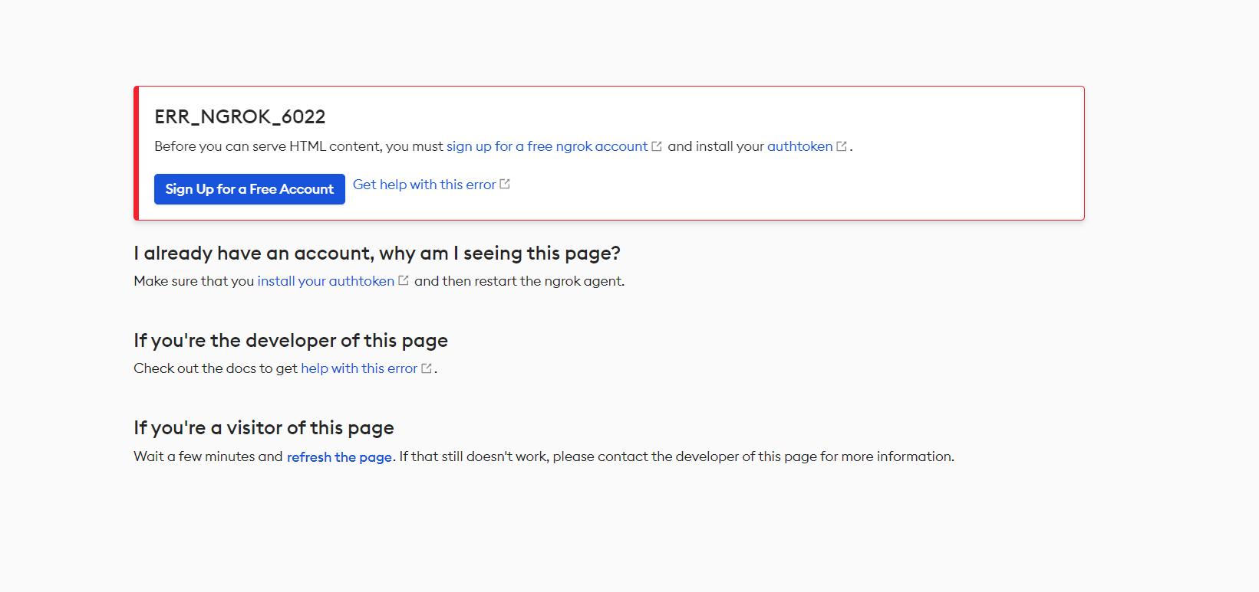

EI ERRO TA ADSBE TAR JONNO AMADER AUTHENTICAT EKORATE HB BOSS…

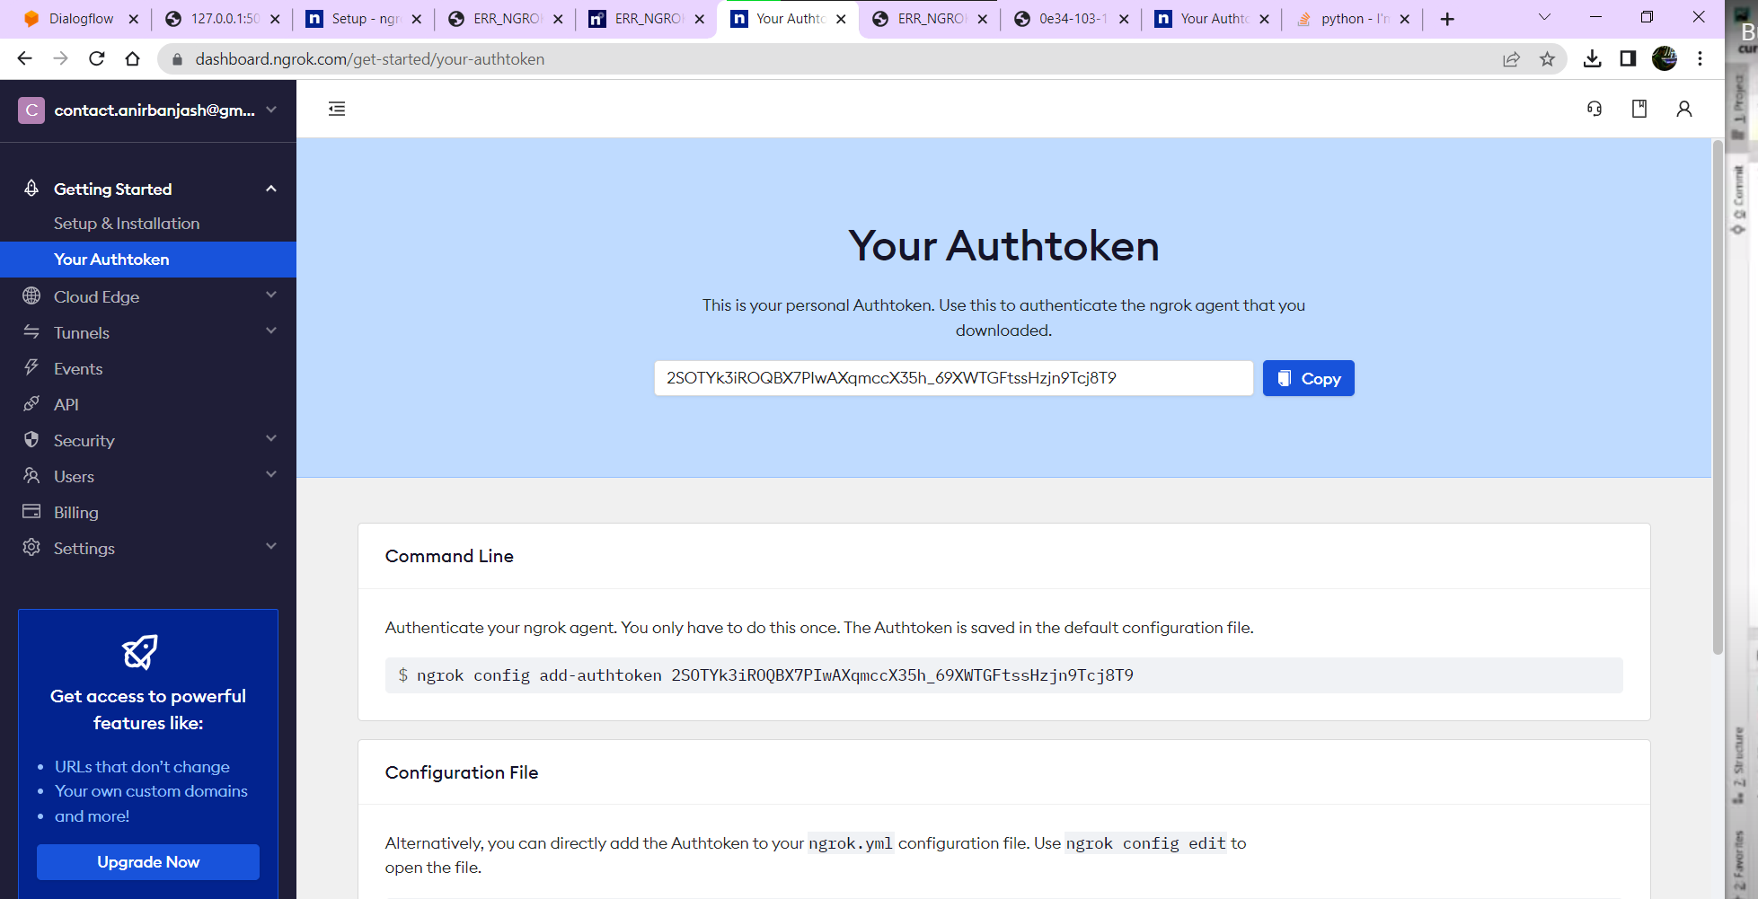

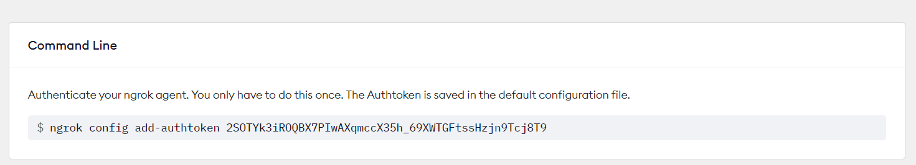

THEN EI COMMANDLINE TA K NGROK TERMINAL PASTE KOREENTER..

AFTER THAT ABAR “ngrok http 5000” byas ebar fprwarding ;ink e click korlei khuleb,,

**Best part holo code e direct change korle ekhaneo show hbe boss**

**Now CHAT BOT ER SATHE CONNECT KORBO..**

**SO DIALOGGFLOW TE JABO**

**NOW AMRA FULL FILL MENT E JABOO THEN EKHANE WEBHOOK ER OPTION ACHE,,,’**

**SO FLASK K DIALOGFLOW AMADER WEBHOOK I BOLE:’**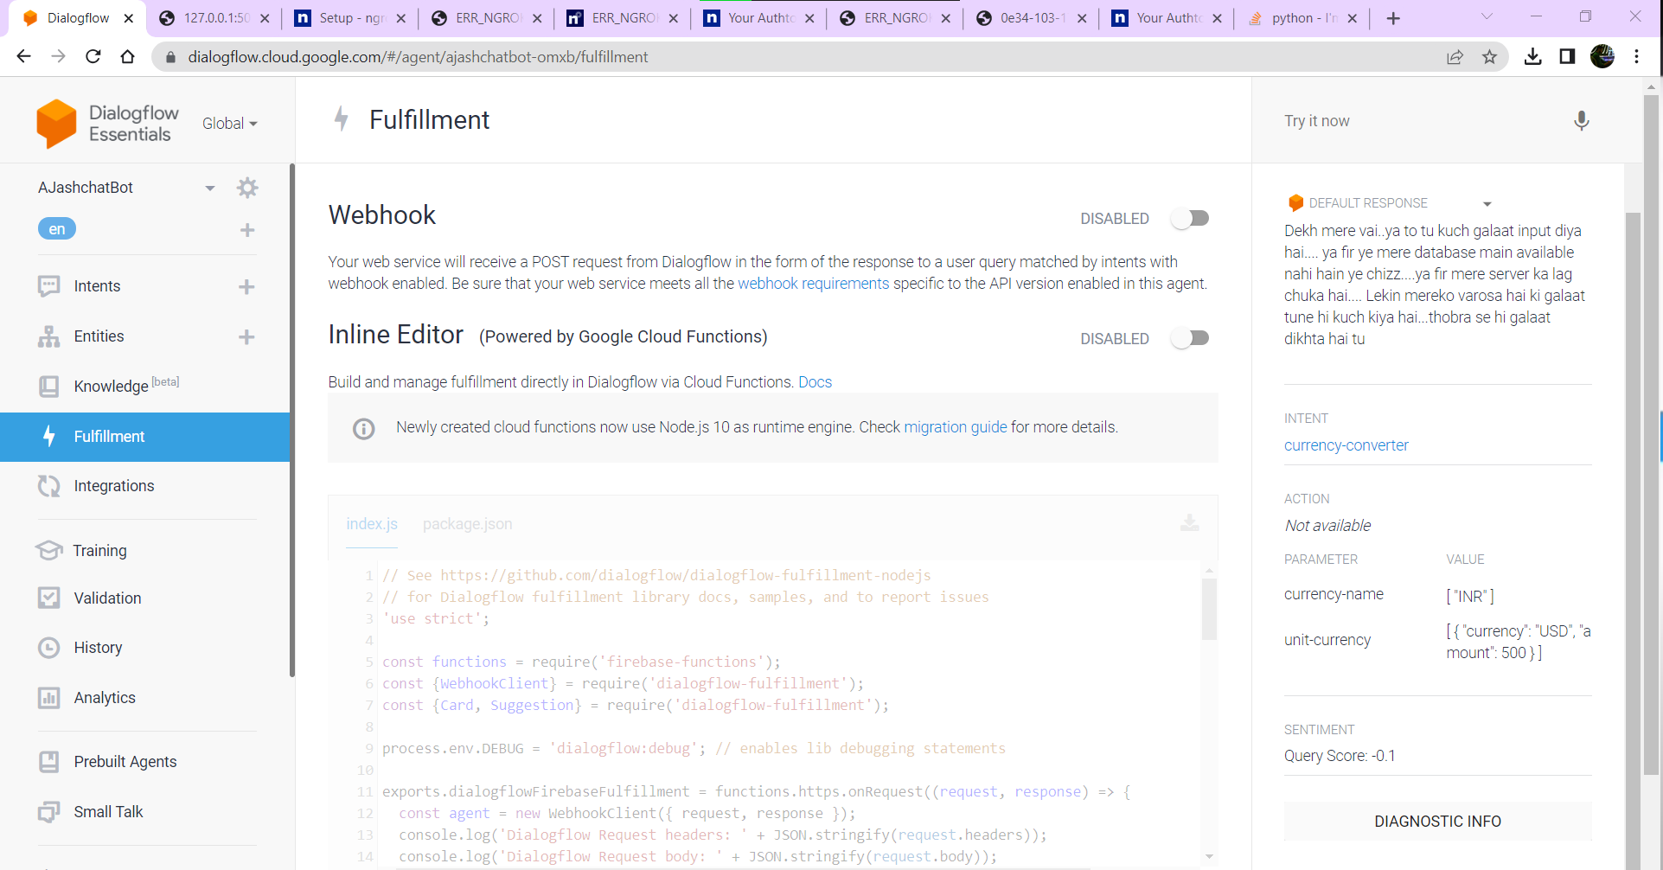

NOW WE HAVE TO ENNEBAL THIS

THEN EKJAANE ENABLE KORE EKTA URL CHAIBE ,,AMADER NGRO ER URL TA DITE HBE

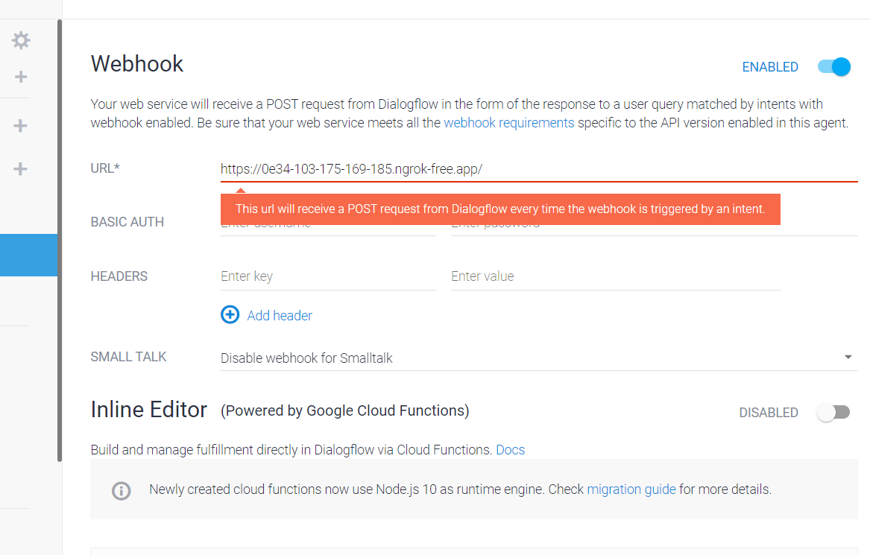

EKAHNE LEKHAI CAHE J YOUR WEB SERVICE EILL RECIIEVE A POST SERVICE…

ETTAR MANE BASICALLY AMADER JSON FILE TA FLUSK APPLICATIION EPABO…



NOW SOBAR AGE REQUEST K IMPORT KORLAM…



NOW POST DATA PACHI SETA SPECIFY KORTE HBE

AAR DATA TA PBO KEMNE??

=>

EVABE JSON FILE TA GET KORE NNEBE

Aar SESE PURO DATA K STRING E CONVERT KORE SCREEN E PRINT KORABO:

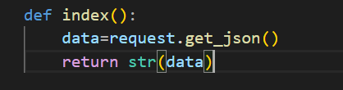

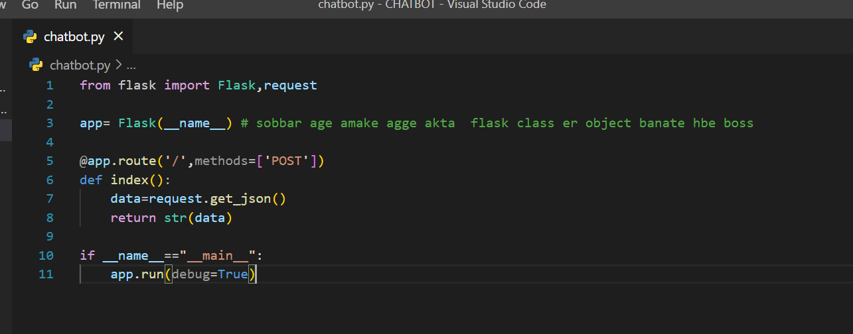

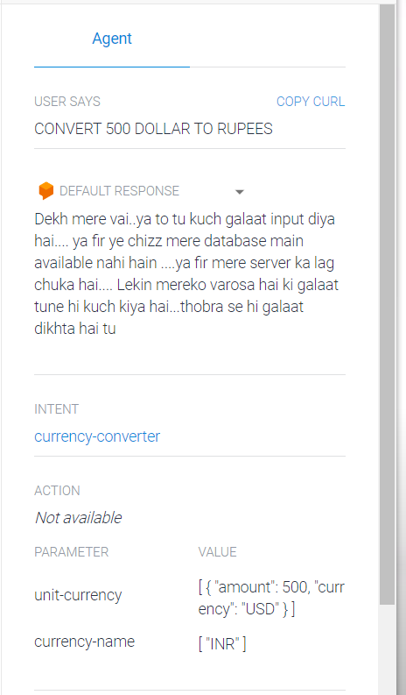

Erom LEKHA MATROI E JSON FILE TA POST KORE PATHIYE DILO AMAR APPLIACTION E AAR A,I SET APRNT KORALAM CONSOLE E ..

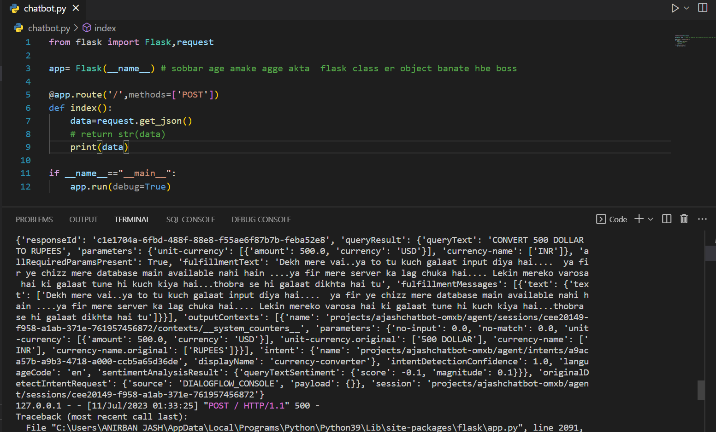

JSON FILE TA CONSOLE E ACHHE..

**\*\*\*FIRST WE HAVE TO UNDERSTAND WHAT IS THE STRUCCTURE OF JSON?**

**==> TAR JONNO CHATBOT THEKE JSON FILE TA COPY KKORTE HBE BOSS…**

**THEN JSONVIWER E JAO AND TEXT E [ASTE KORE WE CANN SEE THEH STRUCTURE**

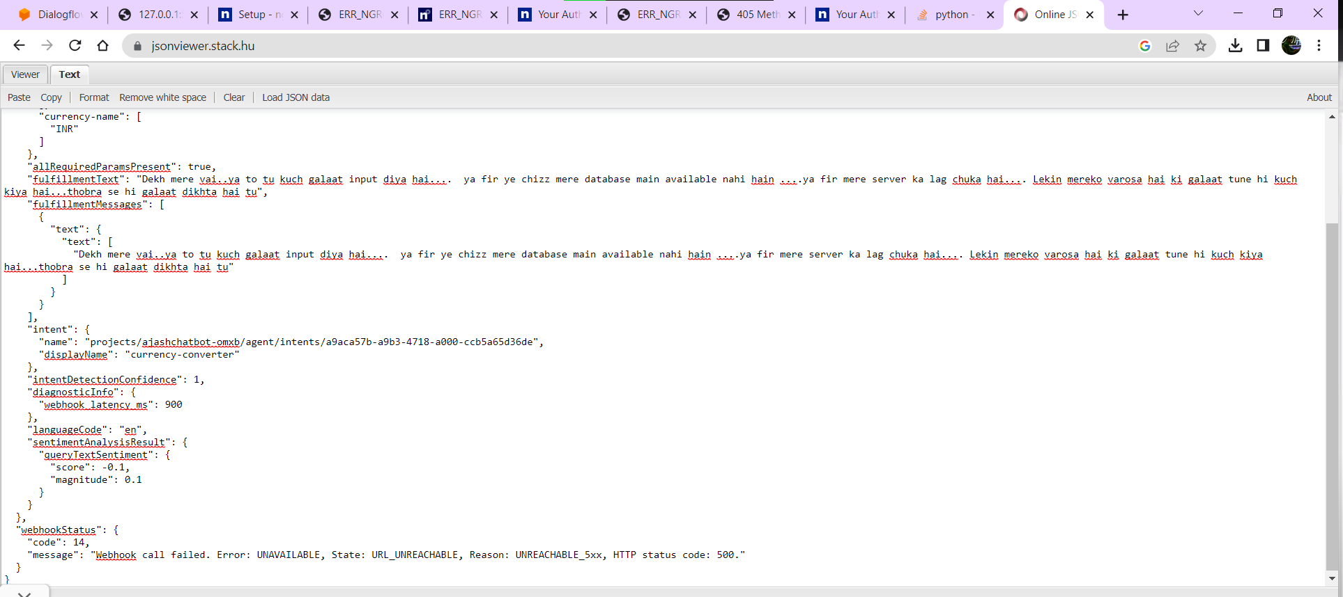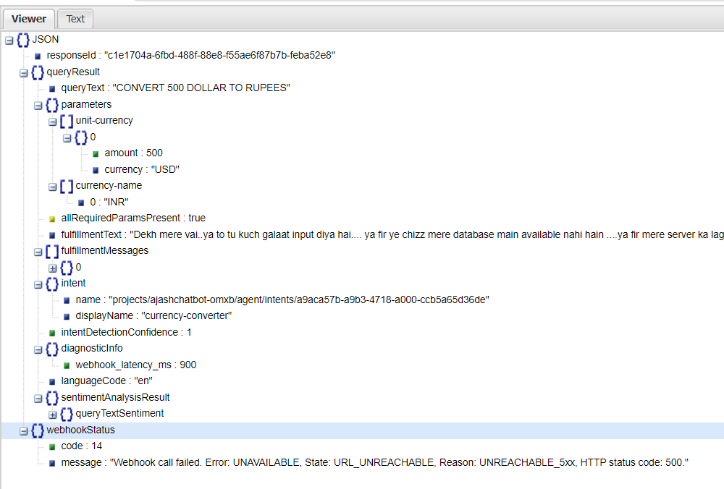

NOW EI STRUCTURE FOLLOW KOR EKOR JABO…AMAR J J PARAMETER GULO OPERATION ER JONNO LAGBE SEGULO FETCH KORBO ,,,

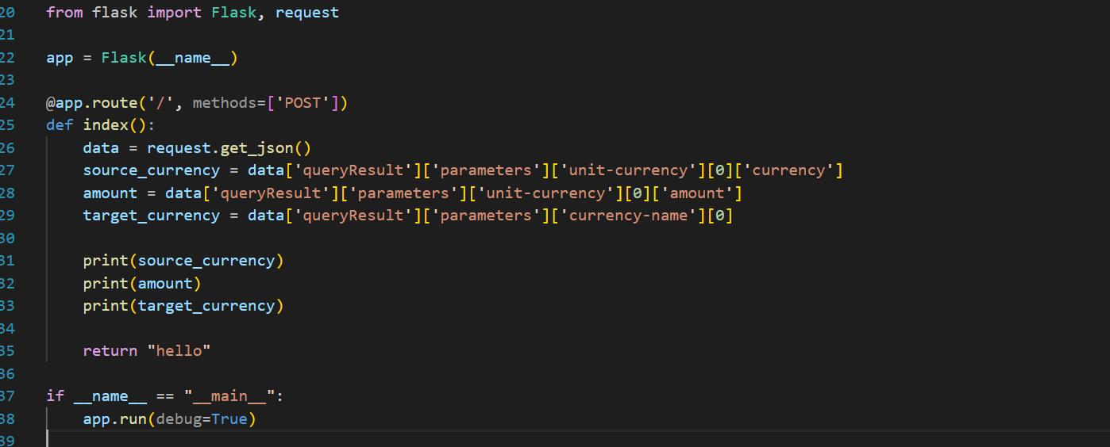

Now STRUCTURE DEKHE DEKHE SEI SEI PARAMATER GULO AMI

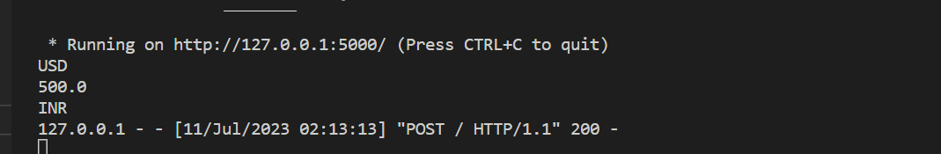

NOW WE NEED CURRENCY CONVERTER API..

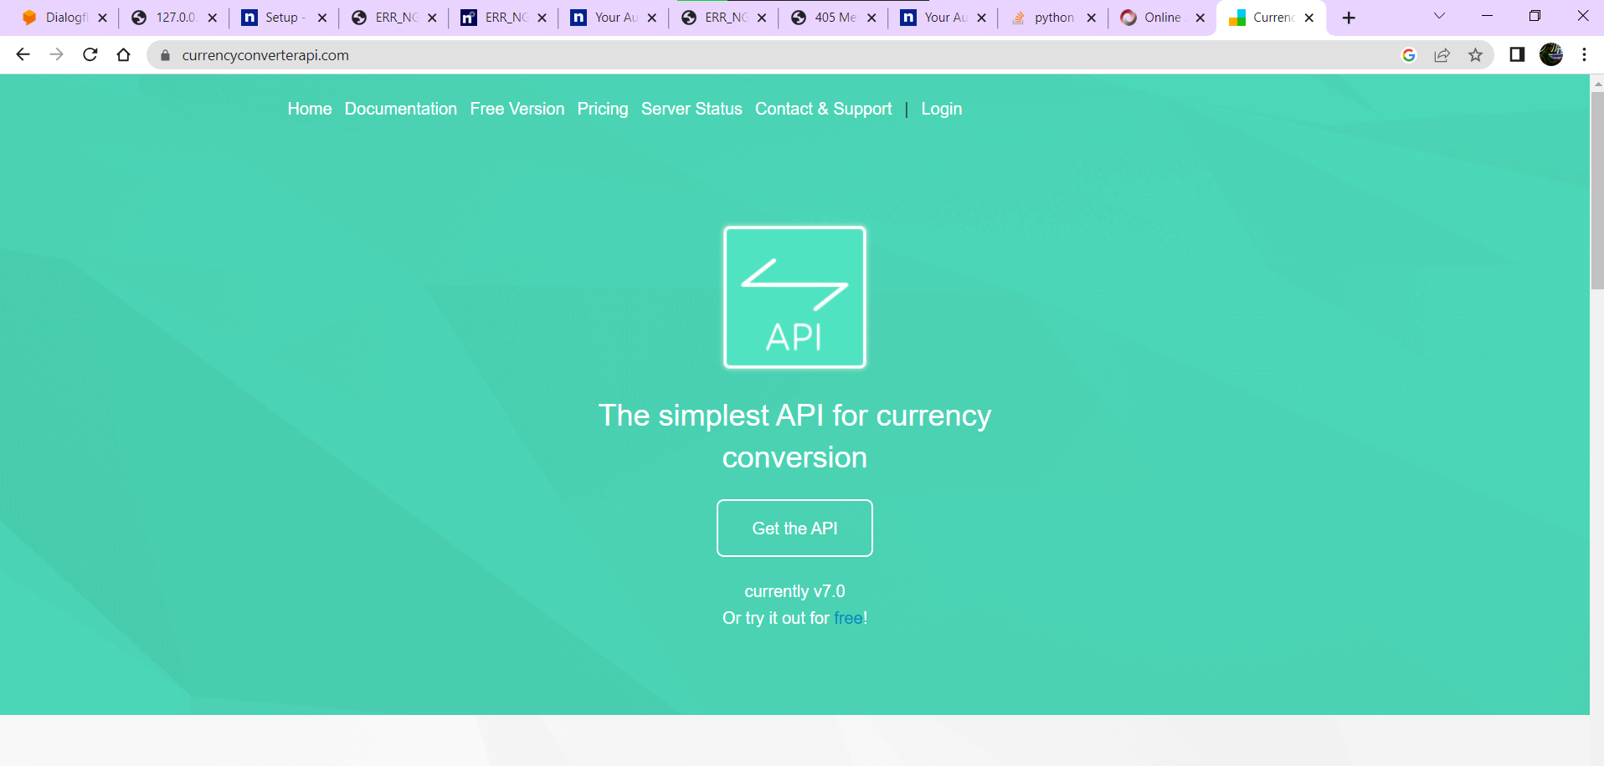

<https://www.currencyconverterapi.com/pricing>

THEN NICHER DIKE FREE VERSION ER LONK DEWA THAKBE BOSS

